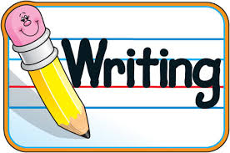
Writing Activities P 1- 3

For each piece of writing try to follow the steps below;
- Draw a picture first.
- Primary 1 write one or two sentences, primary 2 write two or three sentences and primary three write between three and five sentences.
- Make sure each sentence has a capital letter and a full stop.
- Make sure your letters sit on the line and you have finger spaces.
- Colour your picture.
- Read your writing to someone.

You on a snowy day. | You on a sunny day. | You on a windy day. | You on a rainy day.
You at the park. | You at the swimming pool. | You at the beach. | You at a restaurant.
You at a birthday party. | You baking a cake. | You with an ice cream. | You at a fancy-dress party.
A story about a sweet shop. | A story about space. | A story about a dog. | A story about a chocolate factory.
A story about a toy. | A story about school. | A story about something magic. | A story about your favourite time of year.

Or you could use the pages below and write about the pictures using the word boxes to help you.

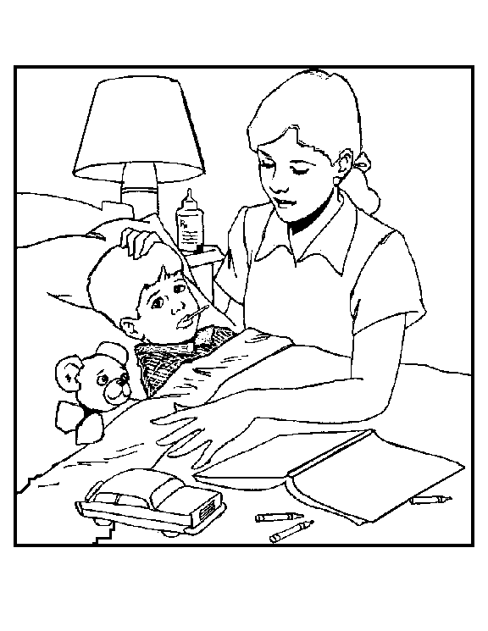

gave | story
medicine | sick
feeling | reading

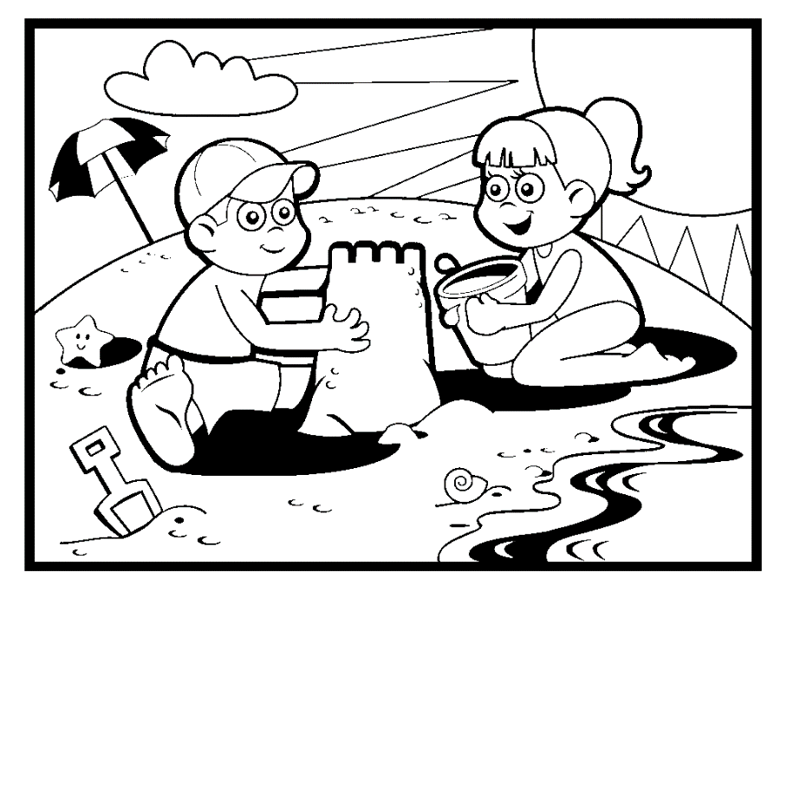

swimming | built
beach | sea
sandcastle

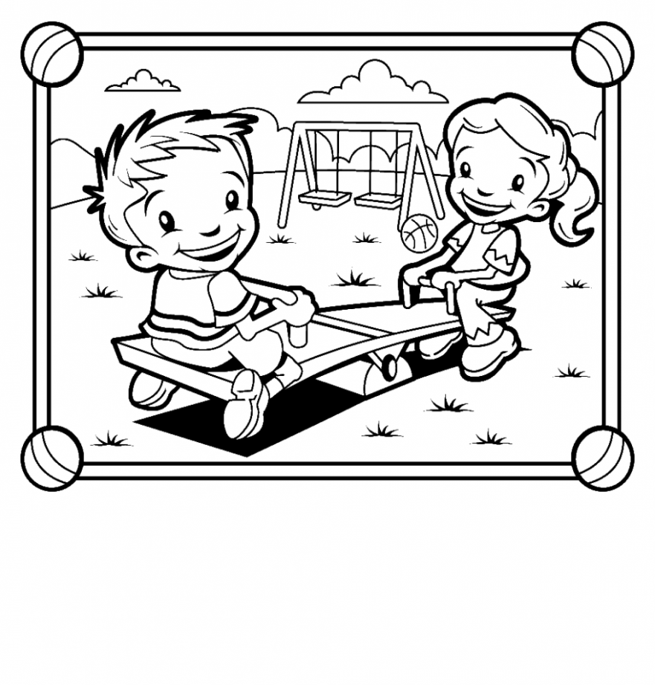
seesaw | played
park | swings

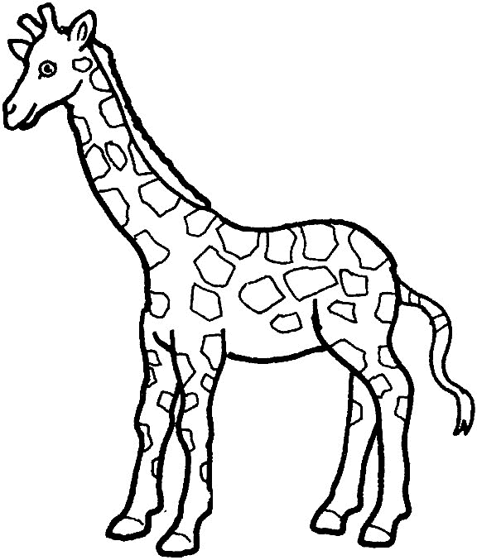

yellow | giraffe
long | neck
tall | brown

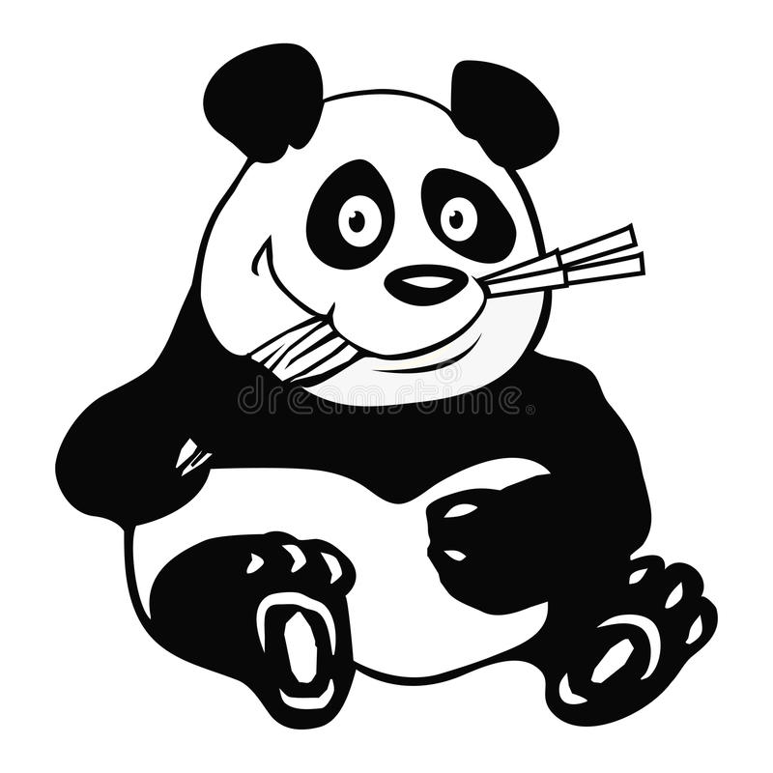
bamboo | black | white
eats | eyes | ears

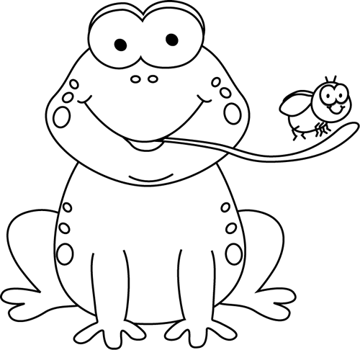

Lilly pad | tongue
likes | long
eat | eyes

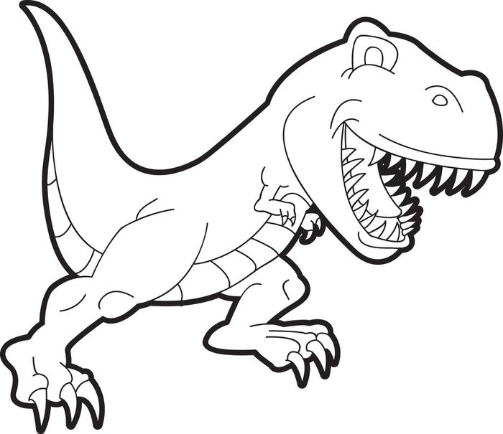

T - Rex | sharp
claws | fierce
tail | teeth
eats



planet | alien
boy | the
rocket | Spaceship

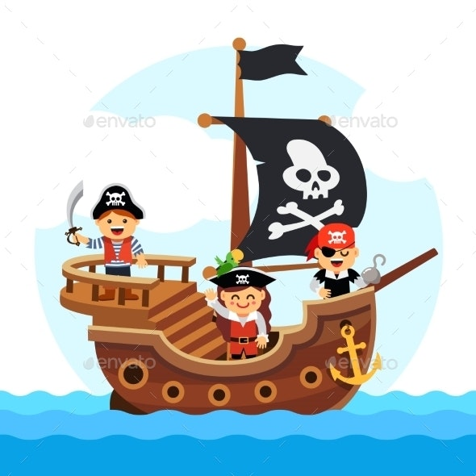

pirate | they
ship | sword
flag | children

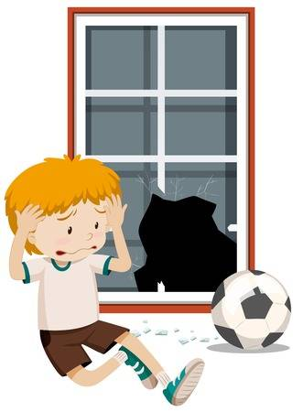

Broke | playing
window | football
kicked

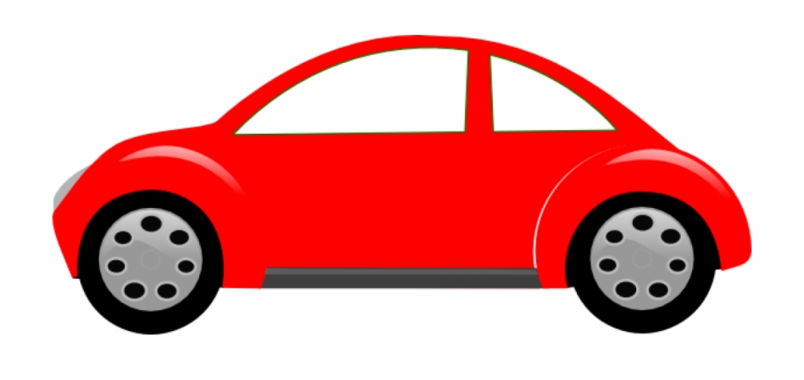

The | car
black | wheels
red

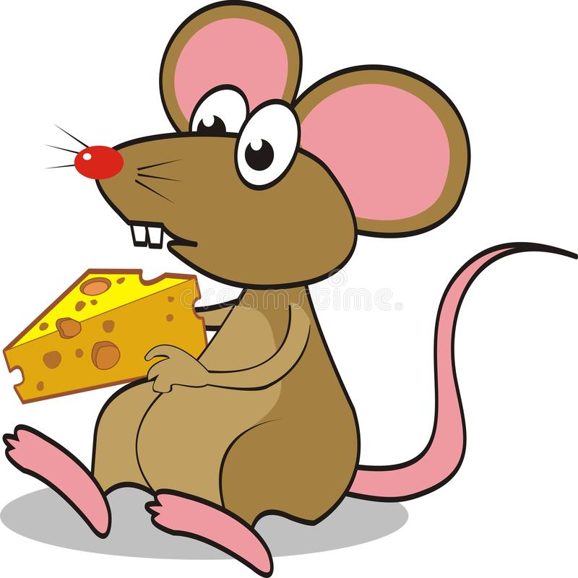

mouse | tail
eating | long
The | the
mouse

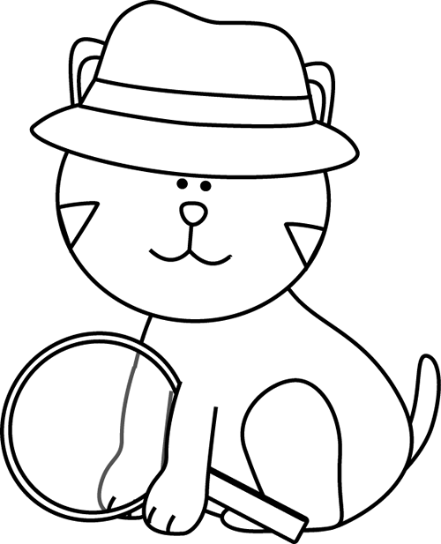

spy | The
glass | the

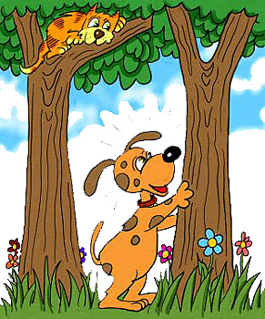

scared | was
barking | tree

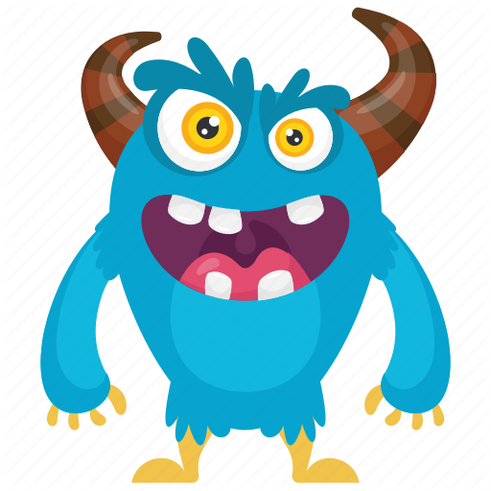

teeth | eyes
yellow | blue
monster | horns
brown | claws

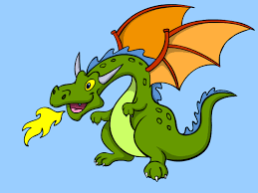

dragon | wings
pointy | horns
fire | tail
breathes

