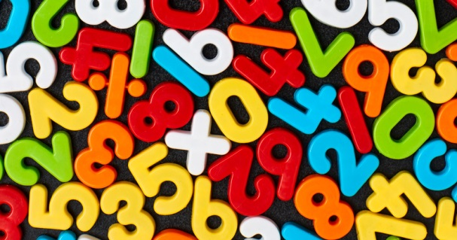
Maths Activities P 4 - 7
Use the example questions to help you. Start at the top of the grid and work your way down. The further you go the harder the tasks!

2 times tables. | 5 times tables. | 10 times tables. | Division facts for the 2 times tables.
  8 x 2
  2 x 6
  4 x 2
  2 x 9
  7 x 2
  5 x 7
  9 x 5
  5 x 3
  6 x 5
  5 x 8
  8 x 10
  10 x 2
  7 x 10
  9 x 10
  10 x 4
  18 ÷ 2
  14 ÷ 2
  20 ÷ 2
  8 ÷ 2
  12 ÷ 2
Division facts for the 5 times tables. | Division facts for the 10 times tables. | Addition facts within 20. | Subtraction facts within 20.
  45 ÷ 5
  25 ÷ 5
  40÷ 5
  15 ÷ 5
  50 ÷ 5
  70 ÷10
  30 ÷10
  90 ÷10
  50 ÷10
  40 ÷10
  What do I add to 14 to make 20? | 8 + 9
  What do I add to 7 to make 20? | 12 + 6
  What do I add to 11 to make 20? | 3 + 11
  What do I add to 18 to make 20? | 2 + 17
  What do I add to 8 to make 20? | 13 + 4
  17 – 8
  13 – 7
  19 – 6
  14 – 8
  16 – 7
3 times tables. | 4 times tables. | Division facts for the 3 times tables. | Division facts for the 4 times tables.
  3 x 8
  4 x 3
  3 x 6
  9 x 3
  5 x 3
  4 x 4
  4 x 9
  4 x 7
  6 x 4
  3 x 4
  15 ÷ 3
  27 ÷ 3
  18 ÷ 3
  12 ÷ 3
  24 ÷ 3
  12 ÷ 4
  24 ÷ 4
  28 ÷ 4
  36 ÷ 4
  16 ÷ 4
6 times tables. | 7 times tables. | Division facts for the 6 times tables. | Division facts for the 7 times tables.
  6 x 6
  8 x 6
  6 x 2
  6 x 9
  5 x 6
  7 x 7
  7 x 3
  8 x 7
  4 x 7
  7 x 9
  30 ÷ 6
  54 ÷ 6
  12 ÷ 6
  48 ÷ 6
  36 ÷ 6
  63 ÷ 7
  28 ÷ 7
  56 ÷ 7
  21 ÷ 7
  49 ÷ 7
8 times tables. | 9 times tables. | Division facts for the 8 times tables. | Division facts for the 9 times tables.
  8 x 4
  9 x 8
  8 x 8
  7 x 8
  8 x 3
  9 x 9
  9 x 3
  6 x 9
  9 x 5
  7 x 9
  24 ÷ 8
  56 ÷ 8
  40 ÷ 8
  72 ÷ 8
  32 ÷ 8
  63 ÷ 9
  45 ÷ 9
  54 ÷ 9
  27 ÷ 9
  81 ÷ 9
Practise chimney sums for addition 2, 3, 4, 5 digit numbers.  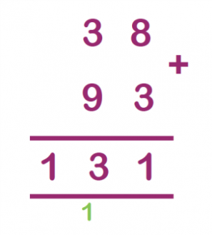 | Practise chimney sums for subtraction, 2,3,4,5 digit numbers.  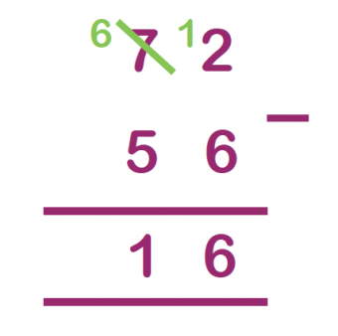 | Practise division sums with 2,3,4,5 digit numbers.  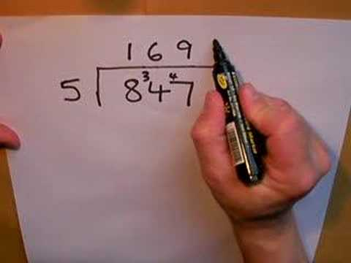 | Practise multiplication sums with 2,3,4,5 digit numbers.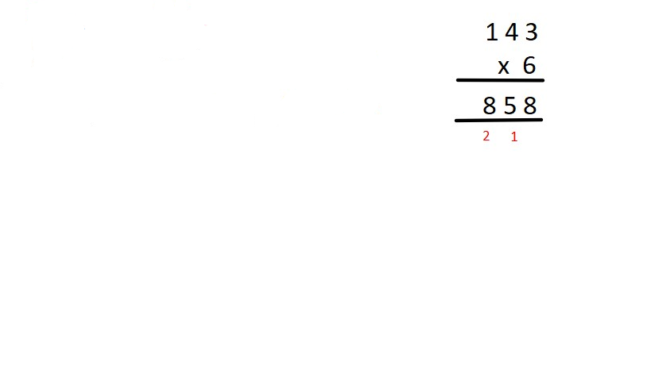
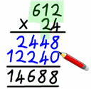
Practise long multiplication.
Name and order the 12 months of the year. | Read o clock and half past times. | Read minutes past times, 5 past, 10 past, quarter past, 20 past and twenty five past. | Read minutes to, twenty five to, twenty to, quarter to, ten to and five to.

