

2023-2024
STANDARDS AND QUALITY REPORT AITHISG INBHEAN IS CÀILEACHD

Portree Primary School


Introduction: Local and National Context
Ro-ràdh: Co-theacsa Ionadail agus Nàiseanta

This Standards and Quality Report is influenced by both Highland and national priorities. These can be summarised as follows:

Highland Priorities  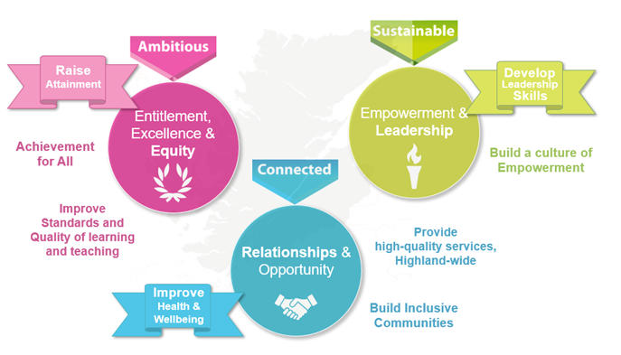  Entitlement, Excellence & Equity:  We will raise attainment and achievement for all, especially for children and young people from disadvantaged circumstances, including rural deprivation. We will focus relentlessly on improving standards and the quality of learning and teaching, to ensure that entitlement, equity and excellence are delivered across the system.  Empowerment & Leadership:  We will develop leadership skills at all levels of the system, for now and the future, building a culture of empowerment and professional capital.  Relationships:  We will maximise health and wellbeing for all children and young people, to give them the best possible start in life. We will ensure every child and young person feels part of the community they live in.  Opportunity:  We will maximise opportunities for our children and young people, and for the wider Highland community and its visitors, through the provision of high-quality services. | National Improvement Framework Priorities  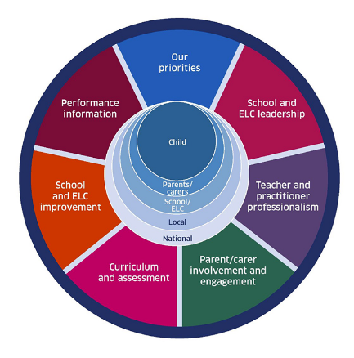  The key priorities outlined in the National Improvement Framework are:  - Placing the human rights and needs of every child and young person at the centre of education  - Improvement in children and young people's health and wellbeing  - Closing the attainment gap between the most and least disadvantaged children and young people  - Improvement in skills and sustained, positive school-leaver destinations for all young people  - Improvement in attainment, particularly in literacy and numeracy.  Self-evaluation  To support self-evaluation, quality indicators from the national evaluative framework How Good Is Our School?4 are referenced.  Links to these sources (and others referenced) can be found here:  National Improvement Framework Improvement Plan  HGIOS? 4 and HGIOELC  Health and Social Care Standards  National Gaelic Language Plan
In this report the following words are used to describe the numbers and proportions used:

All | Almost all | Most | Majority | Less than half | Few
100% | Over 90% | 75% - 90% | 50% - 74% | 15% - 49% | Up to 15%

We are pleased to present our Standards and Quality Report for Session 2023-24. This report forms part of our quality improvement framework and provides important information regarding our school’s progress to date and our next steps in school improvement.

Self-Evaluation for Self-Improvement is at the heart of our practice. We continue to develop our practice in making robust use of evidence as a basis for judgements regarding the impact of our work on our learners. All staff understand that self-evaluation is an integral aspect of our approach to continuous improvement through addressing the 3 key questions:

- How well are we doing?
- How do we know?
- What are we going to do now?

Throughout the year we continuously evaluate what we do and how it makes a difference to our learners. We want to know what is working well for our school community and what needs further improvement. We inform decision making and actions through a continuous process of looking inwards, outwards and forwards.

Looking inwards - starts with those working with our children and young people
We focus on the impact on outcomes for learners. Our self-evaluation processes triangulate information, data, people’s views and observation of practice to measure impact and inform planning for improvement.

Looking outwards - learning from others
Looking to others for new ideas that challenge our practice and support continuous improvement allows us to learn from what works and what doesn’t. This includes practice in other schools, learning communities and learning from educational research.

Looking forwards - creating a vision and planning for implementation
Through leadership at all levels, we anticipate challenges and explore creative solutions. This helps us to create an aspirational vision for our school which shapes our actions and provides a focus for improvement.
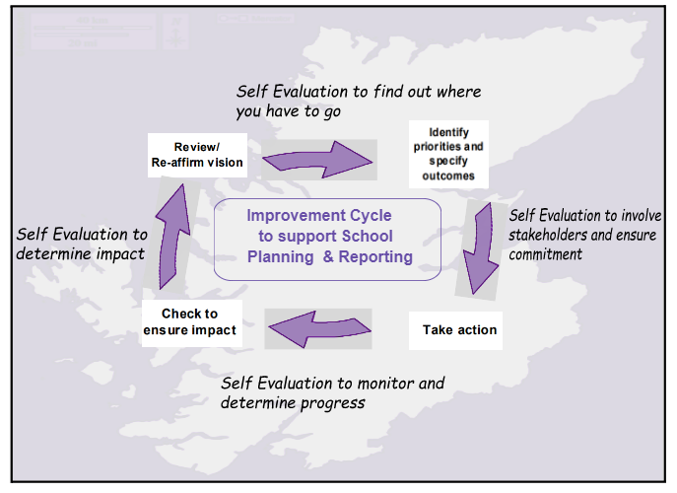
Our children and young people are actively consulted and involved in this process. We also give staff, parents/carers, and other partners the opportunity to participate in discussions and activities to shape our improvement journey.

When we develop our improvement plan, we use key questions at scheduled review times throughout the session to know how well we are progressing towards achieving these positive outcomes and changes.

Together we are working hard to ensure the Highlands is the best place for children and young people to grow up safely, learn, develop and achieve.

With positive experiences, our children and young people will always see the Highlands as home.
Le eòlasan deimhinneach, bidh ar cloinn is ar n-òigridh daonnan a’ faicinn na Gàidhealtachd mar dhachaigh.

David MacLean
Head Teacher
Portree Primary School

School Profile
Pròifil na Sgoile

The following information can be found on Parentzone Scotland. It is important to remember that statistical data alone is not a measure of how well we are doing. All schools are unique. To understand how well we are doing it is important for us to look at a range of different data sources.

Attendance  91% |  | Average Class Size  23.2 |  | Meeting PE Target  Target Met
Pupil Numbers (inc nursery)  139 |  | Teacher Numbers  7.2 FTE (Including 0.6 ASNT and 0.6 CCR) |  | Pupil Teacher Ratio  23.2

P1  6% | P2  13% | P3  12% | P4  12% | P5  19% | P6  14% | P7  24%

SIMD Q1  0.72% | SIMD Q2  22.30% | SIMD Q2  74.82% | SIMD Q3  1.44% | SIMD Q5  0.72% | Unknown  XX%

ASN  31.65% | No ASN  68.35% | FSM  11% | No FSM  89% | EAL  9% | No EAL  91%

2023/24 Proportions of pupils achieving Curriculum for Excellence Levels (P1, P4, P7 combined):
Reading |  | Writing |  | Listening and talking |  | Numeracy
Majority |  | Majority |  | Most |  | Majority

We have had no exclusions this year.

School vision, values and aims
Lèirsinn, luachan agus amasan na sgoile

Portree Primary School values Respect, Determination, Kindness, Enjoyment and Friendship

Our Vision is Achievement For All

AIMS OF PORTREE PRIMARY SCHOOL
1) To have a school that:
- Provides excellent learning and teaching
- Celebrates pupils’ successes
- Involves parents and the community
- Has a positive, inclusive ethos.

2) Encourages pupils to be confident individuals, successful learners, responsible citizens and effective contributors
3) Encourages pupils to do their best and behave well
4) Carries out assessment and reports and gives feedback to pupils and parents
5) Pupils, staff, parents and the community are proud of
6) Has a safe, stimulating environment where pupils learn skills for learning, life and work
7) Has good relationships with other schools and the local community.
8) Provides learning that is relevant to both local and wider contexts and an ever changing society

Objectives
All pupils should know that they have a responsibility to ensure
• That learning is the priority
• They show respect, courtesy and consideration towards all members of the school community
• They are honest and co-operative with others
• They follow the rules and procedures of the school.

Teachers/ support staff will
• Teach effectively without disruption.
• Address the needs of all pupils.
• Make positive contact with parents.
• Act as positive role models.
• Develop personally and professionally.

Parents will
• Feel confident that their children are growing personally, socially and academically.
• Know that their children will receive support when they need it.
• Feel welcome in school to discuss their children’s progress in a positive atmosphere.

All members of the school community are expected to contribute positively to the wider community by:
• Promoting a positive image of the school
• Respecting members of the wider community and their property

Review of progress for session
Ath-sgrùdadh air adhartas airson an t-seisein

These projects are linked to the vision and priorities for Scottish Education based on delivering excellence and equity. Parent/Carer information is available here.

School Priority:
Literacy

Purpose:

To improve pupil attainment in literacy.

Progress:  - All teaching staff have undertaken a comprehensive training programme on literacy including Talk for Writing (fiction), phonics, wraparound spelling, writing in P1-3, writing in P4-7.  - Staff have begun to use aspects of training in planning and delivering lessons.  - Teachers undertook peer monitoring visits with a focus on literacy in order to share new approaches to literacy teaching.  - The Highland Literacy Framework has been adopted as the progression used across the school for the teaching and assessment of literacy.  - Self-evaluation of current practice has highlighted phonic instruction as an area of development need. | Impact:  - Teachers are beginning to embed new strategies for supporting literacy in their lessons. This is having a positive impact on pupil engagement.  - HMIE Inspection report January 2024 noted that teachers are effectively implementing new approaches to teaching writing. As a result, children’s engagement in writing and level of vocabulary used in texts is improving.  - Pupil feedback through Pupil Voice Committee was that a majority of pupils had noticed that they were doing more writing in lessons.  - Most parent respondents to evaluation survey thought that this was a worthwhile priority.  - Overall, good progress has been made in this area.
Next steps:

Improving attainment in literacy will continue to be a priority of the school. Further efforts will be made to embed the training that staff have received this year into teaching and learning across the school. Teachers will need more time to become comfortable with using the Highland Literacy Framework to plan and deliver lessons, and to assess progress in literacy. A whole school approach to the teaching of phonics is under development and will be rolled-out in session 2024-25.

The process for the identification of dyslexia has changed in recent years, and our staff will be undergoing training to ensure that they are able to engage fully with the new model.

School Priority:
Assessment and Moderation

Purpose:

To imporove staff confidence in judging pupil CfE levels. To increase consitency across the school, and to be make judgements which are consitsent with colleagues across our Associated Schools Group (ASG).

Progress:  Content:  - ASG moderation session attended by all teaching staff.  - School moderation activities involving all teaching staff, using literacy rubrics to benchmark pupil work  - Termly Attainment meetings have helped support a consistency of approach across the school.  - Ongoing sampling of jotters and planning documents support consistency.  - P1, P4, P7 teachers using National Standardised Assessment (NSA) data to support their assessment judgements.  - P2, P3, P5, P6 teachers using Scottish Online Formative Assessment (SOFA) data to support their assessment judgements. | Impact:  - Staff confidence survey before and after moderation activities show a slight increase in confidence at judging a level.  - Positive staff feedback on moderation activities, and requests that these are built into the school’s self-evaluation calendar.  - Sharing practice with other schools in the ASG has been useful as a starting point to ensure consistent approach to assessment across the area.  - Teachers have started to use literacy rubrics to support their professional judgement on individual pieces of work, and during internal moderation sessions.  - Teachers have used SOFAs this session and have fed back that these were a useful tool in the assessment process – usually as a way of confirming their assessment judgements.  - Sampling of class work has shown that consistency of practice is continuing to improve.  - Most parent respondents to evaluation survey thought that this was a worthwhile priority.  - Overall, good progress has been made in this area.
Next steps:

Moderation and assessment will continue to be a priority in the school. As part of next year’s school improvement plan, staff will undergo further training on this area. Efforts to improve consistency through moderation within the school and more widely as part of the ASG will continue.

National standardised assessments will continue to be used alongside the SOFA assessments. SOFA assessments will now be used at the start and end of each school session which will support teachers in their professional judgements and help to monitor pupil progress over the year.

School Priority:
Gain Eco-Schools Green Flag Status

Purpose:

The School lost it’s ‘Green Flag’ status during COVID, and would like to have this reinstated. Eco action is a key part of learning for sustainability.

Progress:  - Eco action plan has been submitted to Eco-Schools and has been accepted.  - Litter has been targeted around the school through a ‘magpies’ rota (pupils who are responsible for picking up litter after breaktimes).  - Litter picks around the school and the wider village have taken place on several occasions this session.  - Recycling has been targeted through the purchase of new bins for each classroom which are emptied by pupils on a rota weekly.  - Compost bins are in place outside to collect fruit peels/etc. Compost to be used on our allotments.  - An active pupil eco-committee has been meeting regularly to support eco projects.  - The school grounds have been targeted, with playground planters, and improvements to the school nature walk.  - Our school allotment has been used regularly by a few classes.  - Eco-Committee have taken responsibility for feeding back to the wider school about actions taken. | Impact:  - A significant reduction in litter around the school has been noticed. Pupils take ownership of keeping the school clean and tidy and feel a sense of responsibility to do so.  - Classroom recycling is now more visible, and pupils now have more ownership over this.  - Pupils have a greater understanding of what to recycle and why.  - Some of the waste generated in the school is now being turned into compost to be used on our allotment. This has supported some pupils in gaining a better understanding of sustainable practices.  - Pupils involved in eco-committee have developed their own confidence in leading an initiative in the school and are comfortable sharing progress with their peers.  - Overall, good progress has been made in this area.
Next steps:

Eco action will continue, with a view to the school achieving Green Flag status during the 2024-25 session. Targets in the action plan will continue, however efforts to ensure a greater whole school focus on climate action will be made. It will be important to ensure that targets within the action plan become embedded into the everyday life of the school.

Progress and impact of Pupil Equity Fund
Adhartas agus buaidh Maoin Cothromas Sgoilearan

The majority of our Pupil Equity Fund (PEF) this year was spent on staffing. We started the session with 1 day per week of teacher time and two days per week of PSA time. Unfortunately due to staff leaving their posts we were unable to maintain this consistently throughout the session.
However the focused learning activities on areas such as literacy, numeracy and science had a positive impact on learners. The evaluation exercise completed in June 2024 showed that clear progress in each identified are of need was made by most pupils involved in the PEF groups.

Wider achievements
Coileanaidhean nas fharsainge

We are proud of all of the wider achievements our school has had success with. For example:

Strong Community Engagement:
- Regular Community Café events have had a high turnout. These events have raised thousands of pounds for charities such as Skye and Lochalsh Young Carers, Mary’s Meals, Cancer Research and MND UK.
- Links with Radio Skye via the ‘Kid Experts’ programme and advertisements for Community Café.
- Participation in ‘Skye Week’ events.

Extra Curricular:
- Volunteer run after school clubs such as Running club, Girls Football, Shinty have taken place throughout the year. These have generally been popular and well attended, and parent feedback has shown how valued these opportunities are.
- Our pupils have attended a variety of sporting events such as Cross Country, Swimming Championships, Soccer 7s, and Shinty. We have had some fantastic success in these areas such as the P7 team winning the Soccer 7s tournament, a P7 girl finishing first overall in swimming championships, and a strong placing performance by our cross country team.
- Participation in Local Mod for the first time in several years. Our P1-3 pupils enjoyed learning and performing their Gaelic action songs.

Health & wellbeing
- Regular SHANARRI assemblies. Pupils have developed a greater understanding of the wellbeing indicators and are now much more confident to talk about these.
- Weekly dance lessons from Skyedance have been very popular amongst pupils.
- Weekly swimming lessons have developed pupil confidence in the water.

Celebrating Success
- We continue to celebrate success through regular success assemblies and our Value Awards and WOW certificate system.
- Success is shared with the school community in weekly newsletter, and also through our social media pages.

Comments from learners, families, stakeholders and staff
Beachdan bho luchd-ionnsachaidh, teaghlaichean, luchd-ùidhe is luchd-obrach

Leaners

Almost all learners report that they are happy with the quality of teaching in the school, and most report that they feel safe and treated fairly and with respect.

Learner comments:
- “My favourite thing about the school is the teachers. They are really nice.” (BM P3)
- “I love playing with my buddy. She is kind and the best buddy.” (FS P2).
- “I like playing football and having the timetable for the MUGA.” (NR P3)
- “After school shinty on Monday is the best.” CM (P2)
- “It helps me to learn and it is a nice place.” AR (P2)
- “The playground is really good with all the equipment.” (ZL P5)
- “My favourite is the opportunity for free play, just being able to work with someone on something I like doing.” (IeD P6)
- “I like hanging out with my friends. School is where I can see everyone and it is nice.” (AP P6)

Families

Almost all families reported that their child likes being in the school and that staff treat their child fairly and with respect. Most reported that they are satisfied with the school and would recommend it to other parents.

Family comments: “There is a lovely atmosphere in the school. The children are very polite and respectful to visitors, and you can see that they get on with the staff.” – family member comment.

“He will be sad to leave. The school has been great for his confidence.” – parent of departing P7 boy.

Stakeholders

Most stakeholders thought that partnership working with the school works well.

Stakeholder comments: “I thoroughly enjoyed my sessions with the children.” Skyedance instructor

“The children are a credit to the school and so well mannered” – community member comment after Community Café event.

Staff

Almost all staff reported that they found it rewarding to be a member of staff at the school and felt valued as a part of the school community.

Staff comments: “PPS staff are caring towards staff and pupils alike. Parents and the wider community are invited into the school. There is a selection of afterschool activities - promoting H&WB and team building. Staff receive professional and constructive feedback with developmental suggestions.”

Capacity for continuous improvement
Comas airson leasachadh leantainneach

Using indicators from ‘How Good is our School 4’ together with learner, parent, carer, partner and community feedback we believe we have made the following progress this session:

 | ELC | PRIMARY
QI 1.3  Leadership of change | Choose an item. | Good
QI 2.3  Learning, teaching and assessment | Choose an item. | Good
QI 3.1  Wellbeing, equality and inclusion | Choose an item. | Good
QI 3.2  Raising attainment and achievement/Securing children’s progress | Choose an item. | Good

Our overall evaluation of our capacity for continuous improvement is:
We are confident in our capacity for continous improvement.

Key priorities for improvement planning
Prìomhachasan airson planadh airson leasachadh

Based on feedback from staff, parents and pupils, our priorities for improvement next session shall be on the following areas:
- Literacy
- Assessment and Moderation
- Health & Wellbeing

Planning ahead
A’ planadh air adhart

Full details of the school’s 2024/25 improvement priorities and actions are detailed on the school improvement plan, which can be accessed on our website www.portreeprimaryschool.com or by contacting the school office.

SIMD – The Scottish Index of Multiple Deprivation (SIMD) is a relative measure of deprivation.
ASN – Additional Support Needs
FSM – Free school meal entitlement
EAL – English as an additional language

